Q. Write a program in python to demonstrate bisection method. Aim: To write a program in python to demonstrate bisection method. Formula: Xr = a+b/2
Xr = ((a+b)/2)

Program:
import math

# Function evaluator def f(x, func_str):
return eval(func_str, {"x": x, "math": math})

# Bisection Method
def bisection(func_str, a, b, tol):
if f(a, func_str) * f(b, func_str) > 0:
print("Invalid interval! f(a) and f(b) must have opposite signs.") return

print("\nIter\t a\t b\t Xr\t f(Xr)") iter = 1

while (b - a) / 2 > tol:
Xr = (a + b) / 2
fx = f(Xr, func_str)
print(f"{iter}\t {a:.3f}\t {b:.3f}\t {Xr:.3f}\t {fx:.3f}")

if abs(fx) < tol: break

if f(a, func_str) * fx < 0: b = Xr
else:
a = Xr

iter += 1

print(f"\nApproximate root = {Xr:.3f} (correct to 3 decimal places)") # === Main Program ===
print("=== Bisection Method ===")
func_str = input("Enter the function f(x): ") # Example: x**3 - 4*x + 1
a = float(input("Enter starting value a: ")) # Example: 0
b = float(input("Enter ending value b: ")) # Example: 1 tol = 0.0001 # Accuracy

bisection(func_str, a, b, tol) Result:
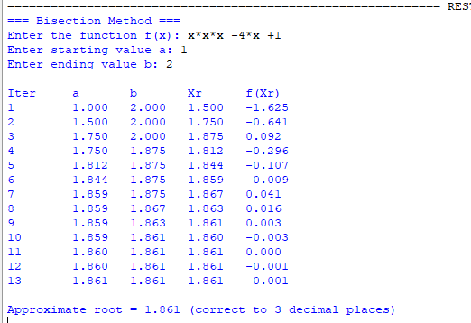
Conclusion: The above program has been executed successfully.

